Lab 4

ECN – 252

19114001 | Abhinav Saini

**Lesson 1** #sets =1, #Blocks/set = 2 and Block size = 4

1. 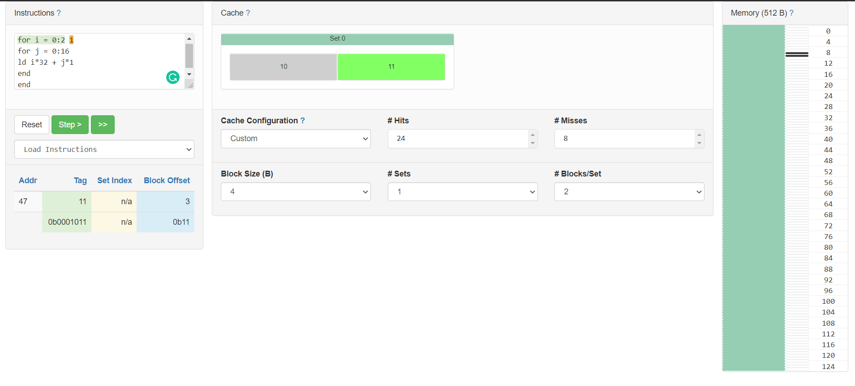**K = 1 , #Hits = 24, #Misses = 8**
2. 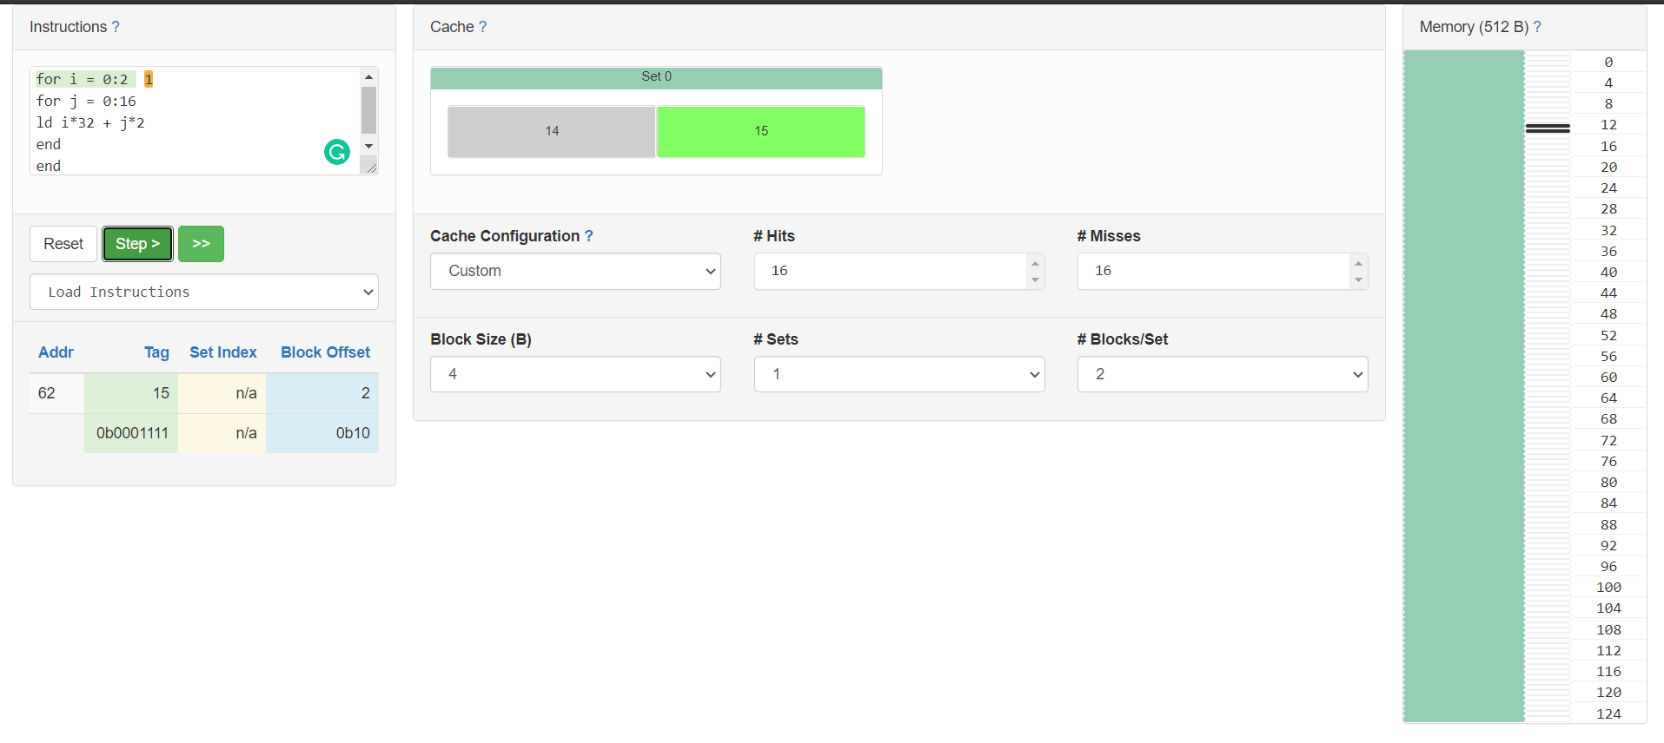**K = 2** , **#Hits = 16 , #Misses = 16**
3. 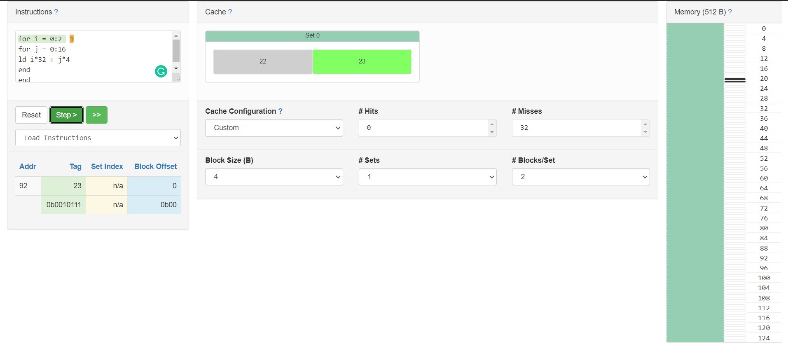**K = 4** , **#Hits = 0, #Misses = 32**

**Lesson 2**

1. 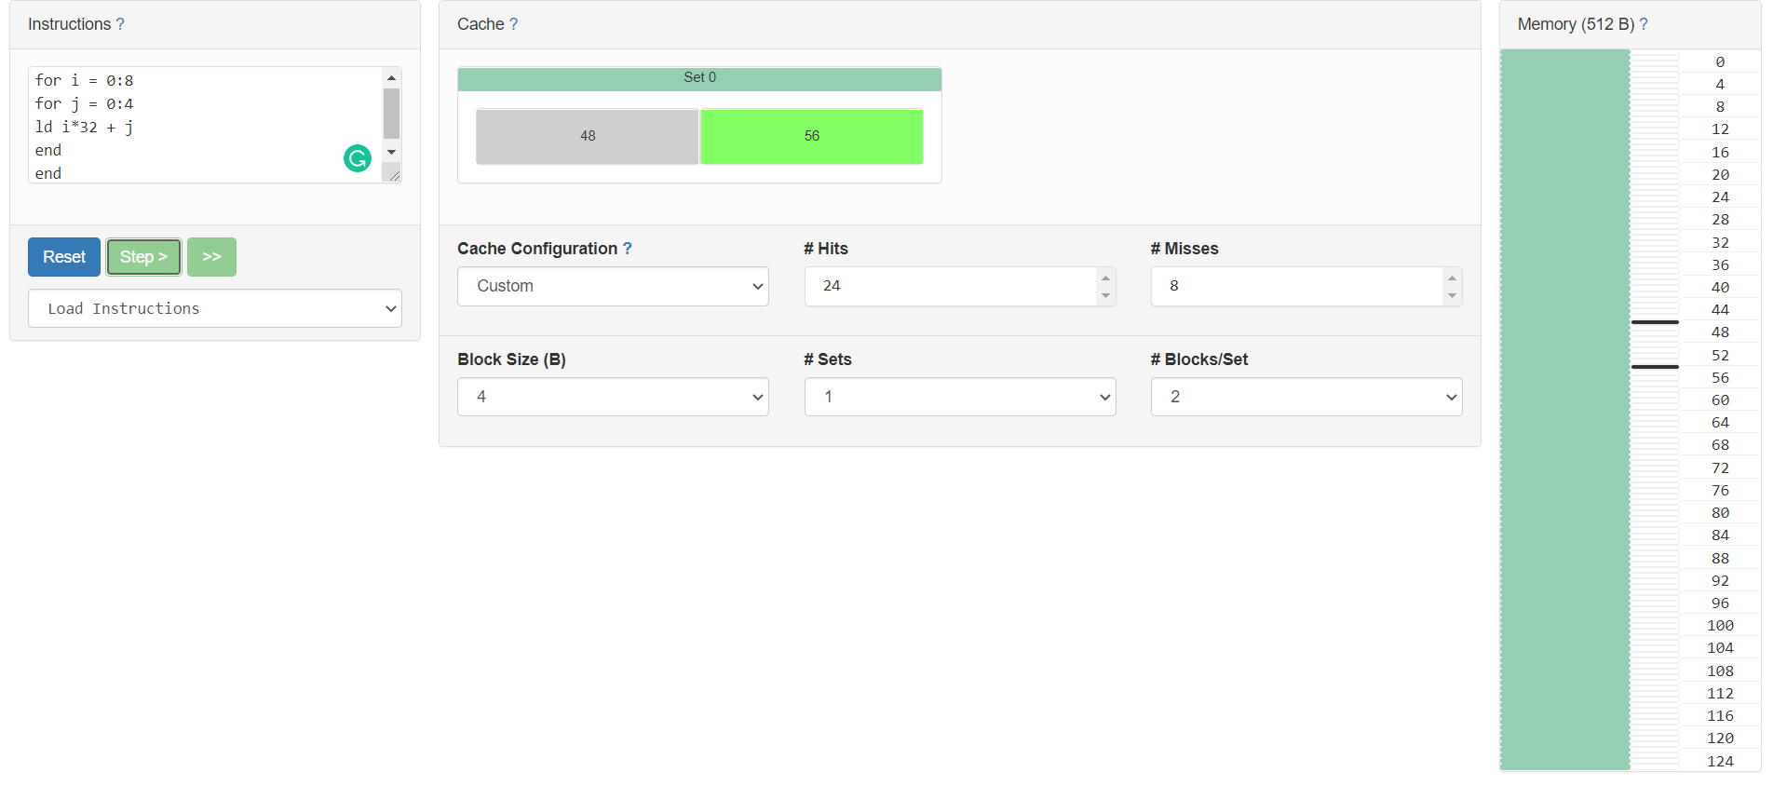**#Hits = 24 , #Misses = 8**
2. **#Hits = 0 , #Misses = 32**

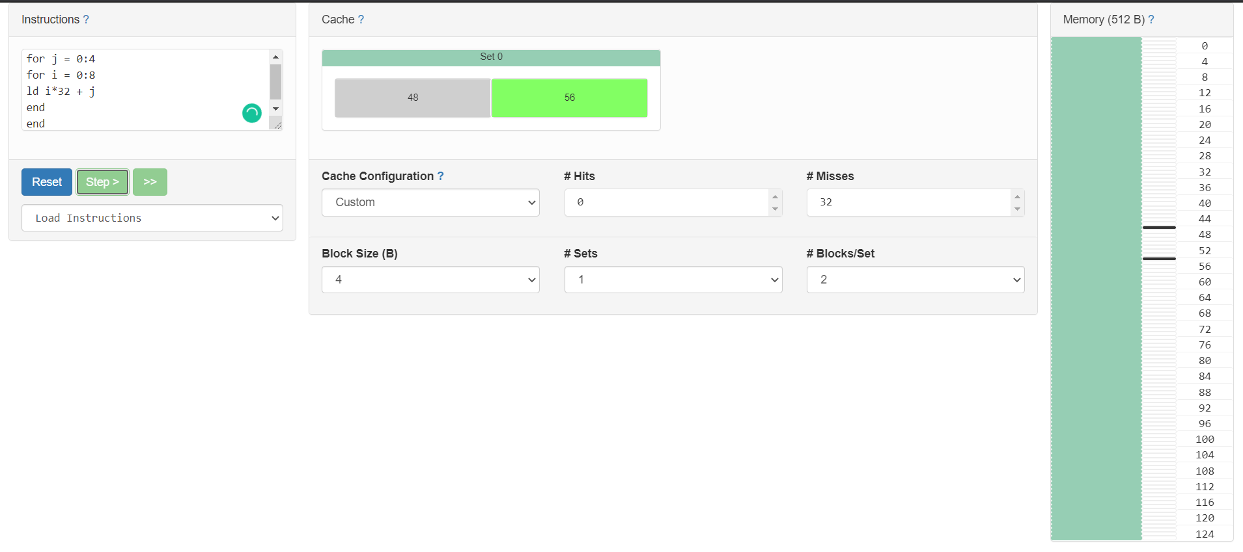

**Lesson 3**

1. 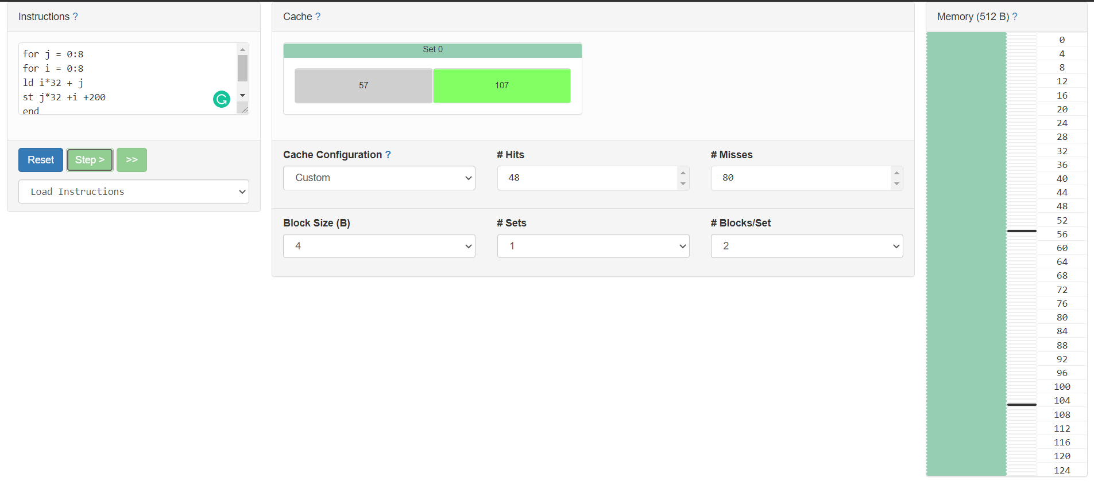**Both ld and st #Hits = 48, #Misses = 80**

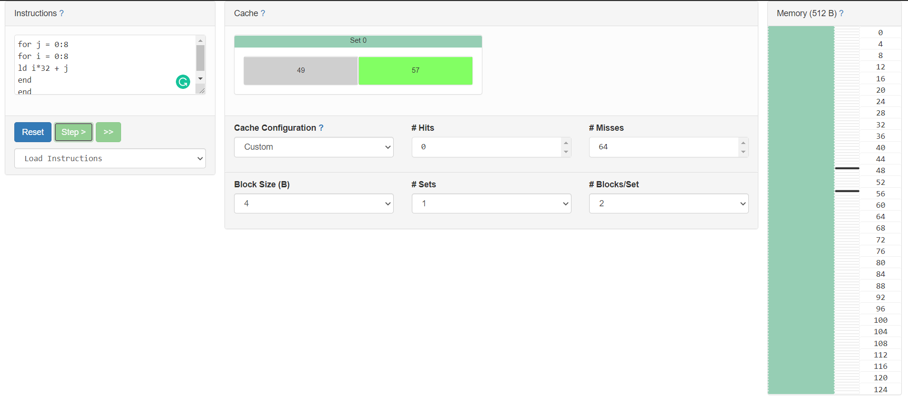**Only ld instruction - #Hits = 0, #Misses = 64**

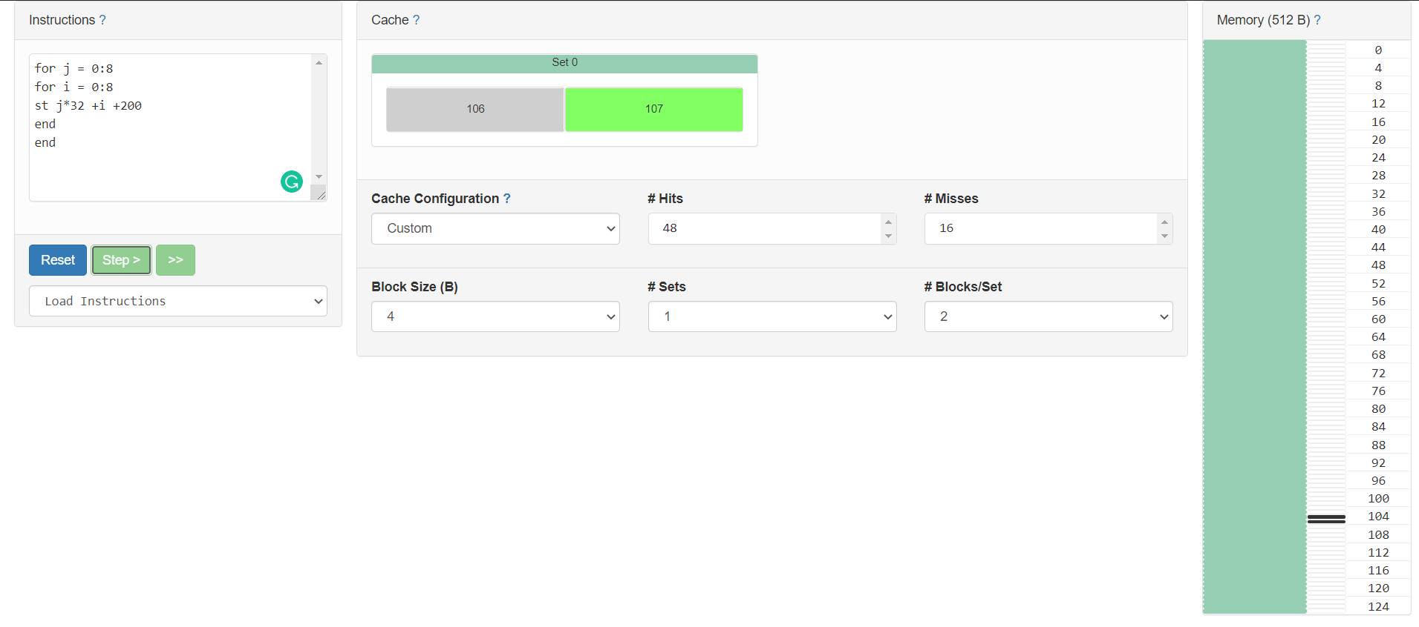**Only st instruction - # Hits = 48, #Misses = 16**

1. 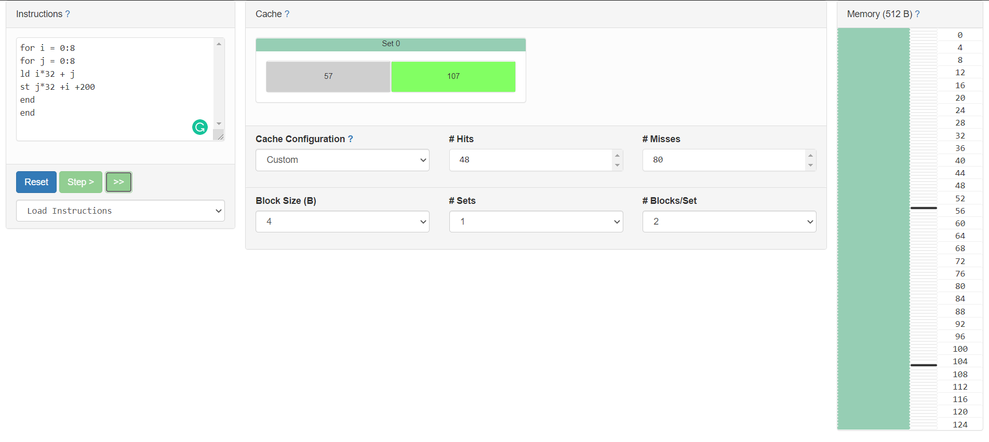**Both ld and st #Hits = 48, #Misses = 80**

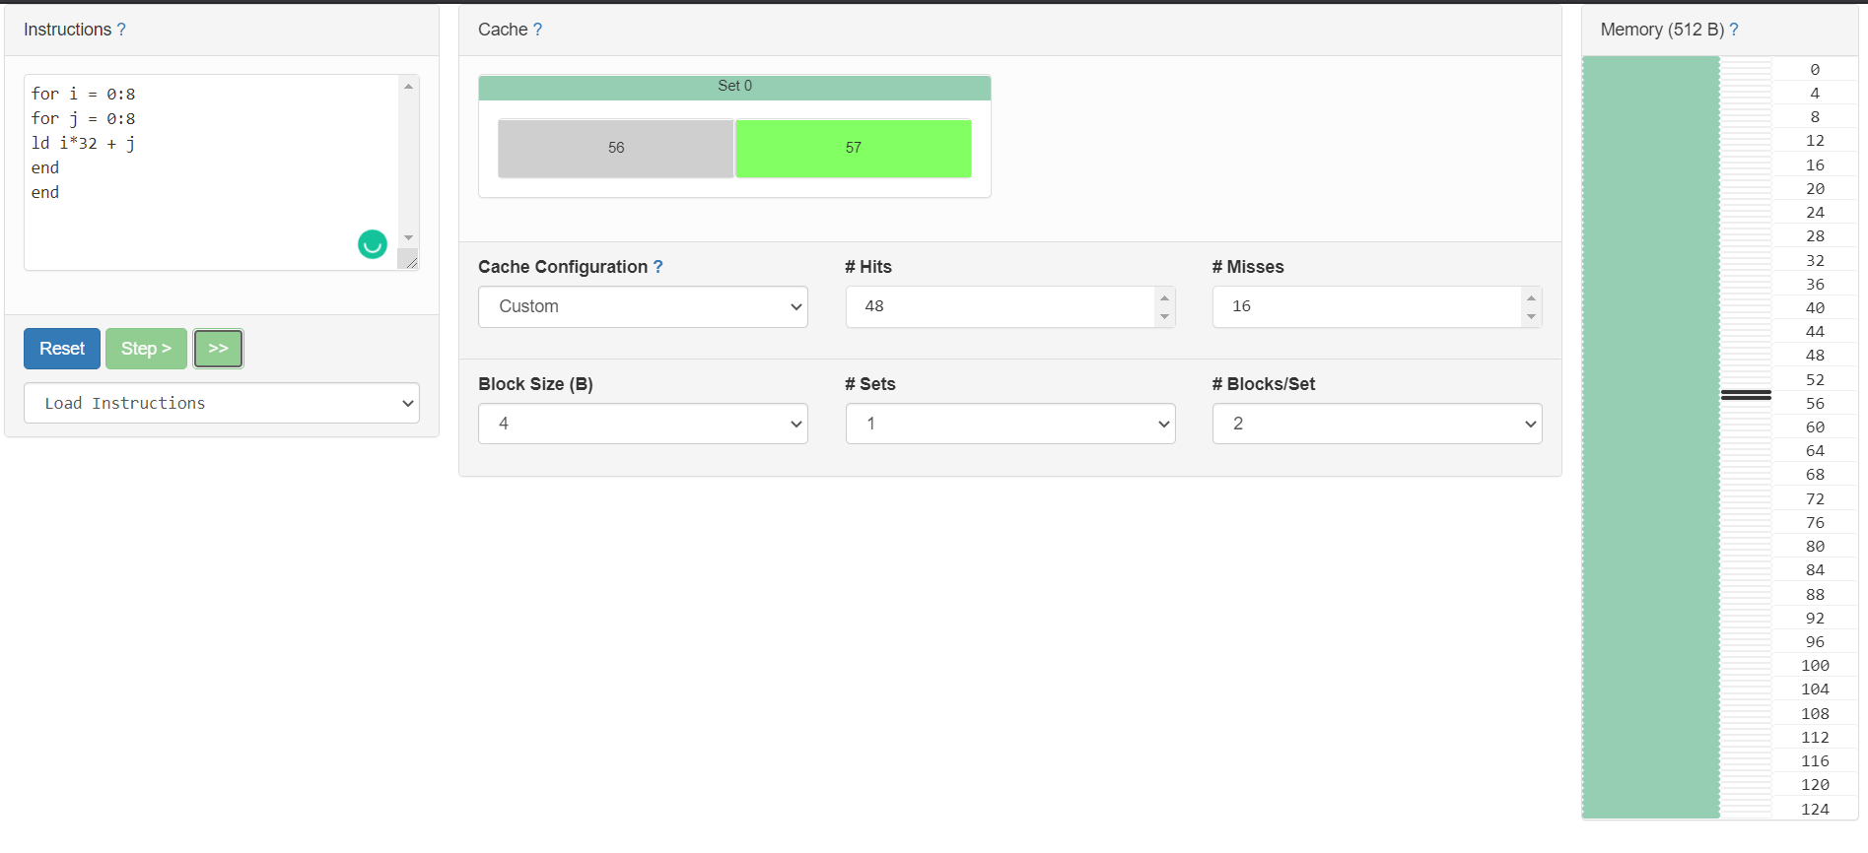**Only ld instruction - #Hits = 48, #Misses = 16**

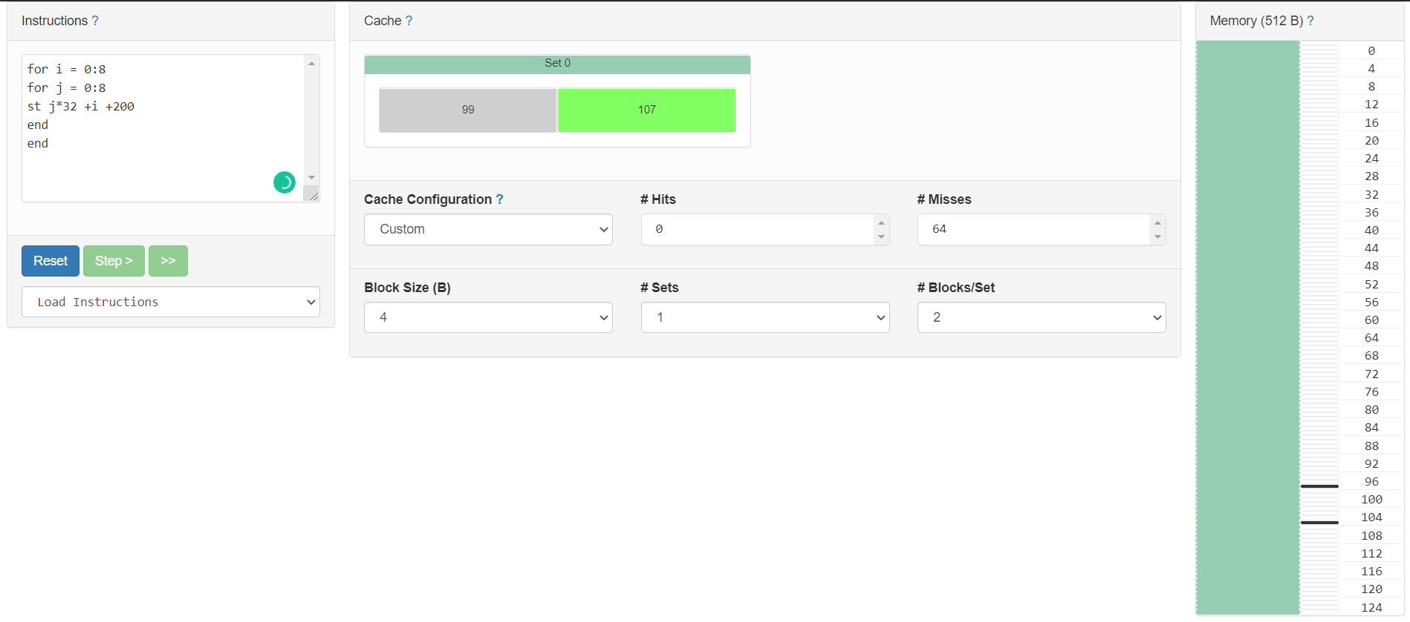**Only st instruction - #Hits = 0, #Misses = 64**

**Lesson 4**

1. **Enrollment No. – 19114001**

**Decimal No. – 19114001.34567**

**Binary No. – 01001011100100011101010000001001**

|  |  |  |
| --- | --- | --- |
| Binary Number | Decimal | Diff |
| 01001011100100011101010000001001 | **19114001.34567** | **0** |
| 01001011100100011101010000000000 | **19113984.0** | **17.34567** |
| 01001011100100011101010000000000 | **19113984.0** | **17.34567** |
| 01001011100100011101000000000000 | **19111936.0** | **2,065.34567** |
| 01001011100100010000000000000000 | **19005440.0** | **1,08,561.34567** |
| 01001011100100000000000000000000 | **18874368.0** | **2,39,633.34567** |
| 01001011000000000000000000000000 | **8388608.0** | **1,07,25,393.34567** |

**Lesson 5**

1. **Binary No. – 01001011100100011101010000001001**

|  |  |  |  |
| --- | --- | --- | --- |
| Error in Bit | Binary Number | Decimal | Diff |
| No error | 01001011100100011101010000001001 | 19114001.34567 | 0 |
| 1 | 00001011100100011101010000001001 | 5.61710034315e-32 | ≈-1,91,14,001.34567 |
| 2 | 01101011100100011101010000001001 | 3.52591103118e+26 | ≈3.52591103118e+26 |
| 3 | 01011011100100011101010000001001 | 8.20940134857e+16 | ≈8.20940134666e+16 |
| 4 | 01000011100100011101010000001001 | 291.656524658 | -1,91,13,709.689145342 |
| 5 | 01001111100100011101010000001001 | 4893184512.0 | 4,87,40,70,510.65433 |
| 6 | 01001001100100011101010000001001 | 1194625.125 | -1,79,19,376.22067 |
| 7 | 01001010100100011101010000001001 | 4778500.5 | -1,43,35,500.84567 |
| 8 | 01001011000100011101010000001001 | 9557001.0 | -95,57,000.34567 |
| 9 | 01001011110100011101010000001001 | 27502610.0 | 83,88,608.65433 |

**Lesson 6**

|  |  |  |
| --- | --- | --- |
| Memory | Write Latency (ns) | Leakage Power (mW) |
| SRAM | 0.870329ns | 82.2568mW |
| eDRAM | 0.426995ns | 12.0617mW |
| STTRAM | 4.69172ns | 37.3457mW |
| ReRAM | 8.71368ns | 101.578mW |